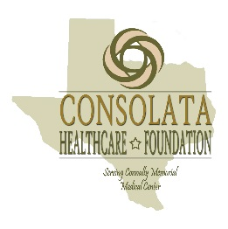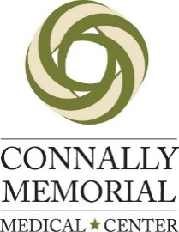
Consolata Healthcare Foundation
Mail payment to: 499 10th Street Floresville, TX 78114
Contact Veronica Collazo Phone: (830)251-3850 Fax: (830) 393-1301 or
Email consolata@connallymmc.org
Make Check Payable to Consolata Healthcare Foundation

Team Name:_____________________________________________

- Name: ______________________________________________________________
E-mail: _____________________________________________________________
Address: ________________________________ City:_______________________
Phone: __________________________ Handicap:_________________

- Name: ______________________________________________________________
E-mail: _____________________________________________________________
Address: ________________________________ City:_______________________
Phone: __________________________ Handicap:_________________

- Name: ______________________________________________________________
E-mail: _____________________________________________________________
Address: ________________________________ City:_______________________
Phone: __________________________ Handicap:_________________

- Name: ______________________________________________________________
E-mail: _____________________________________________________________
Address: ________________________________ City:_______________________
Phone: __________________________ Handicap:_________________

