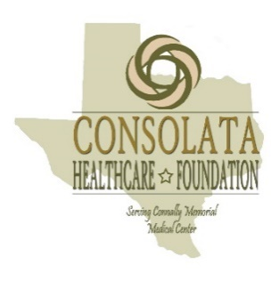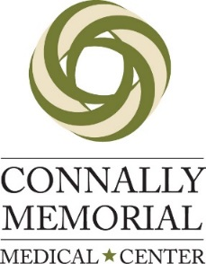
CHF Sponsorship Commitment Form
Fax this form to Connally Memorial Medical Center at (830)393-1301
email consolata@connallymmc.org or call Veronica Collazo at (830)251-3850

□ SOLD-Victoria Emergency Associates Ace Level Sponsor $1,000.00
Company name & logo on all related tournament documents, Sponsorship Package, Opportunity for course display, Media/Press Releases, Hole Sign

□ $25,000 Hole in One Sponsor $1,000
Signage, Media/Press Releases, Hole Sign

□SOLD-Dr. Ekmark- Eagle Level Sponsor $500.00
Signage, Media/Press Releases, Hole Sign

□ Longest Drive Sponsor $500.00
Signage, Media/Press Releases, Hole Sign

□ Closest to the Pin Sponsor $500.00
Signage, Media/Press Releases, Hole Sign

□ SOLD-Craig Nieschweitz PLLC- Putting Contest Sponsor $500.00
Signage, Media/Press Releases, Hole Sign

□ Birdie Sponsor $300.00
Media/Press Releases, Hole Sign

□ Business Opportunity Hole Sponsor $300.00
Signage, Media/Press Releases, Hole Sign
Opportunity to set up own tent and promote your business on the course

□ Hole Sign Sponsor $200.00

Company Name: _________________________________________________________
Address: _______________________________________________________________
Phone Number: ______________________Email: _______________________________

